MAYORS CLEARANCE

TO WHOM IT MAY CONCERN:

This is to certify that Kyle Joseph Dominic Alvis Ragudo 24 years of age, single presently residing at Barangay Purok a Dackel, Vigan City, Ilocos Sur, has no derogatory records in this office as of this date.
Issued u pon the request of above name person for PNP Enlistment.


Given this 25th day of March 2026 at Vigan City, Ilocos Sur.



___________________

Bearer

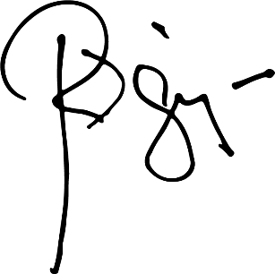

HON.RANDOLF “RANDY” V. SINGSON
City Mayor

OR# - 2554161
Issued on: March 25, 2026

